**NSDD Flavor Drill February 2025**

Document LA-UR-25-?????. Approved for public release; distribution is unlimited.

Title: NSDD Flavor Drill February 2025

Authors: David J. Mercer, Jennifer Auxier, and Brian Jennings. Thanks to Angela Moore at Pacific Northwest National Laboratory and Will Johnson at Lawrence Livermore National Laboratory.

Date: 15 Feb 2025

**Introduction**

This is the NSDD “Flavor of the Month” drill for February 2025. The difficulty level is 5/10.

This exercise focuses on a new QR code file format, which allows spectra to be transferred using photographs. Although HPGe spectra are typically too large for this format, lower-resolution spectra can be compressed and stored in QR codes.

A full overview is available here:📄 [**Spectra in a QR Code (SAND2023-08778O)**](https://sandialabs.github.io/InterSpec/tutorials/references/20230829_spectra_in_a_QR-code_SAND2023-08778O.pdf)

The QR file format is currently available on VeriFinder instruments with a recent firmware update and is expected to be supported by Kromek devices soon. [Will Johnson edit???]

This format is compatible with InterSpec Version 1.0.12 or later. You can download the latest InterSpec software here:  
📥 [**Download InterSpec**](https://github.com/sandialabs/InterSpec/releases)

To open a QR spectrum, simply import the image file (JPG, BMP, PNG, SVG) into InterSpec. [Will Johnson edit: what about InterSpec on a camera-enabled device ???].

* Open the InterSpec application.
* If InterSpec is already running, you may wish to select “File” → “Clear Session…”.
* Drag and drop the QR image file onto the application as “Foreground”
* When asked “Would you like to use the QR code…” select “Yes”.

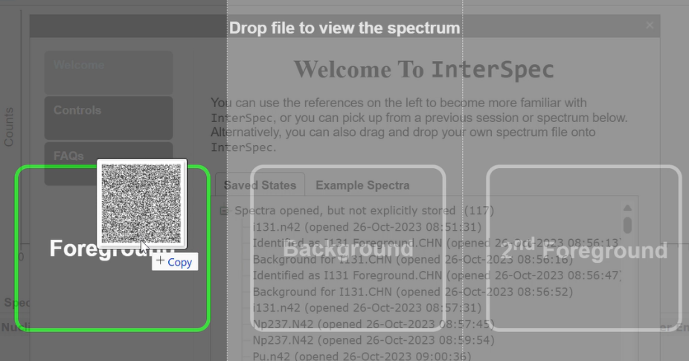 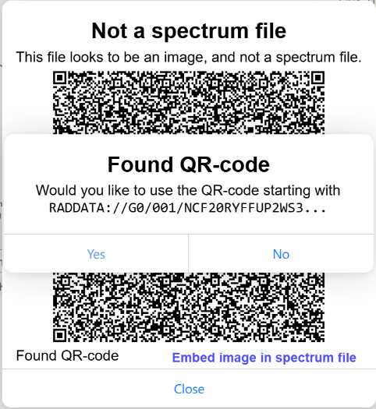

All files are available at [SPECIFY LOCATION], including spectrum files in CHN format as an option if you are unable to use the QR format.

Question 1: **(Optional) Please enter your name or team name and organization.**

The next two questions are based on the file *Q2 QR Image.png*. This image encodes both foreground and background spectra. A corresponding plot, generated by InterSpec, is also provided.

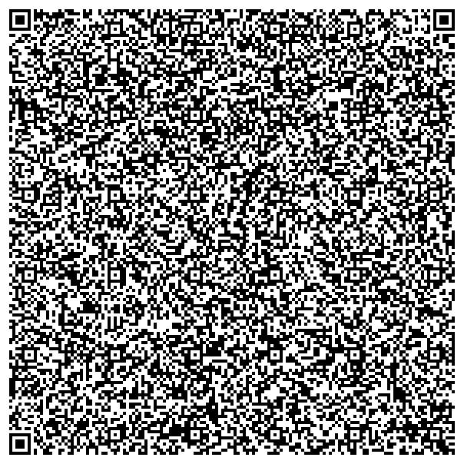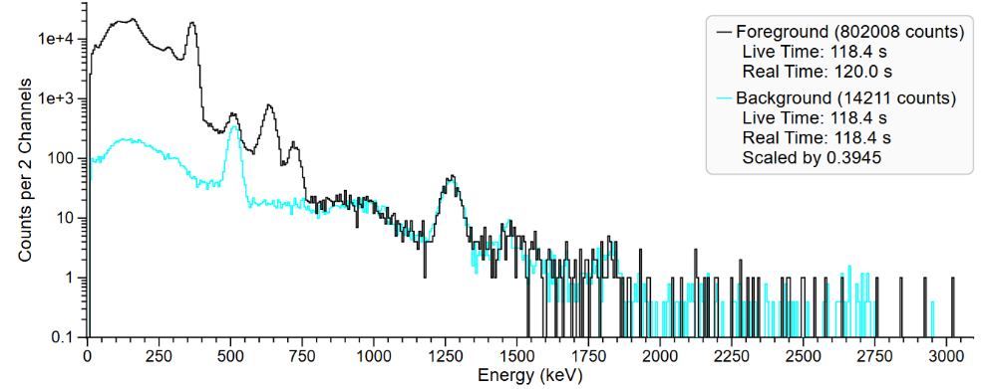

Question 2: **Which is the most likely radionuclide in the foreground?**

1. Au-196
2. Ba-133
3. I-131
4. Pd-103
5. Tl-200

Question 3: **Which radionuclide is used as an internal energy calibration source in the Verifinder, visible in the background?**

1. Cs-137
2. F-18
3. K-40
4. Lu-176
5. Na-22

Question 4 is based on the file *Q4 QR Photo.jpg*, which is a photograph of a VeriFinder instrument screen displaying a QR code. To increase the challenge, the converted spectrum is not provided here, so you must use InterSpec.

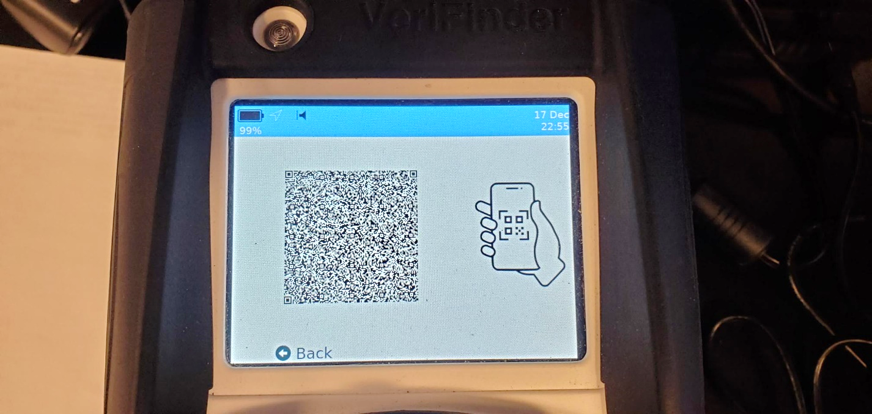

**Which radionuclide is evident in the foreground?**

1. Am-241
2. Ba-133
3. Co-60
4. Cs-137
5. U-238

Question 5 is based on the file *Q5 QR Photo.jpg*, from a photograph of the Verifinder instrument screen.

The answer key from the March 2021 Flavor Drill, Question 7, may be a useful reference. It is available at [SPECIFY LINK???]

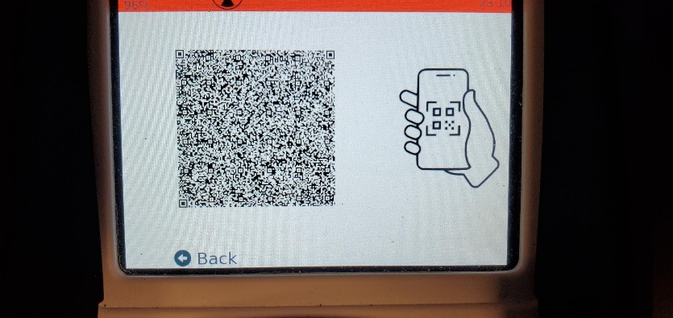 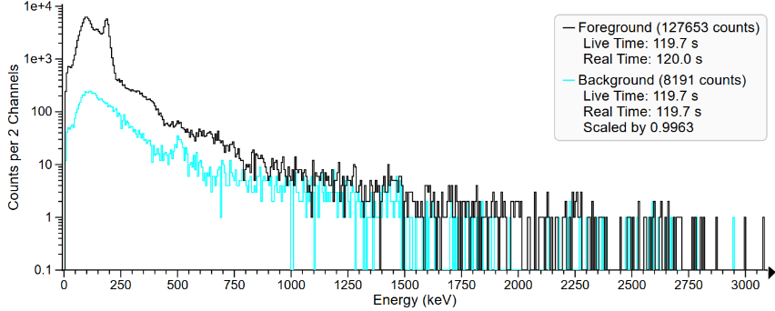

**Which radioactive material is visible?**

1. Plutonium
2. Natural or Depleted Uranium
3. Enriched Uranium (U-235)
4. Cu-67
5. Ho-166m
6. Uranium-233
7. Neptunium-237

Question 6 is based on a plutonium measurement using a VeriFinder instrument. The file *Q6 QR Photo.jpg* is a photograph of the instrument screen.

The answer key from the November 2020 Flavor Drill, Question 7, may be a useful reference. It is available at [SPECIFY LINK???]

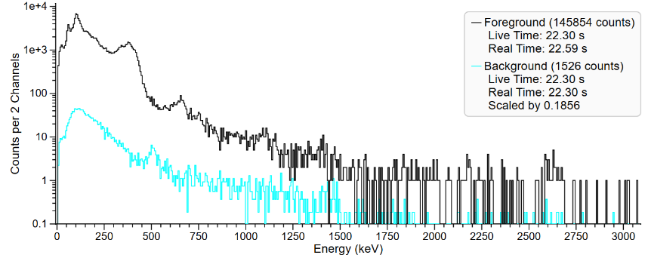

**Which plutonium burnup level is most likely?**

1. Weapons Grade (low burnup)
2. Reactor Grade (high burnup)

Question 7 is based on the file *Q7 URL.txt*. This is a spectrum of a different plutonium sample that has been stored in a URL variation of QR encoding (some instruments offer this option for easier email transmission). The URL is ASCII text that stores the spectrum data. The file may be dragged-and-dropped onto InterSpec just like any other spectrum file. No background spectrum is available.

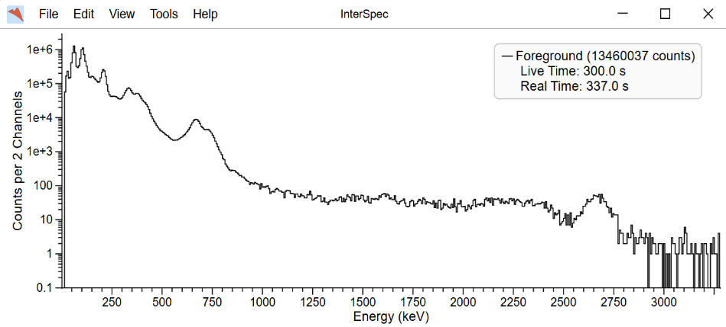

RADDATA://G0/000/NCF2%3ARM%24DEP2Y53%3AMRA4W3%2FJGOR*6M%247UF%20RE%2FH2KF%2BEVJ0J1I1TQR8J1R5IAQH%24VQVN9C35B18%2BG5XZ08D3E%258QPODQ1%20863U2LK2ZR9LY9ESGUT2LVGHV57%3A7XJQ%2512O8476C5HHLX067EKTV%25J6M5OKP6CL6%20AUA-4VPUM8EFG22VLQMQI7DE%252H.2%25N93KIU%2FKTS8IR5WTB%2B%2FN2GMP*9JQCS7DEUSZ-HTR8ZFI-%3AM1UI%2F5QVW6VZDEOFO-GM3USZR0FVHSEXAR%20RR%24PL%3A*7T9TE-2525%20*I%24WN*T4166RJMZMREDMYCR%2BJNVSCV%2BRC%248Q.ENC51-Q9KK07L%24%3AR0KCJGMC187OEF%2B1J9NTW3QXVB%2F09%24V4%25PWIS0%3A4%24*AMXH%25GB8%24T%3AYAJ%25T84SA2ATOJ%25WHNPTUG0L.FP1CI5PT%2FDITO8WGPRG%20E5FFQ9PKYUGOHUTPK%246H.WV5%251%2B*KI8VMTN2JM.RN3VR%24PN811%20ZV%2FWJSZ4VN1OMSVUSDV05%2B6UMUN36CR0%20MEVRF6GSBX0USBE%2F9IP0YQCQD47YKB66JE0S%2F0J-D7KNYHD8%2FO5KAM1W%2F74%3ATB%2BMGE-L%2FAS-KUJ%2BD670Y%2BRF61%255HB%20Q37D%2FVGLZBANFR16UKFIZT19T5NT0U1UV5QRBO%25QTF5F7LV%2F6KF35RA9Y8B%2F29JLRJK6JLLENP3D46Q5NQ8L2A.B%3A%2BV%20MTUN5-6MGGR%2BMD%200HU5EU6POAOH6EG2K.8J4ZRTEUL6RU.ECBBPOA%20XP%2FAQN6K6LMVZTV5Q%2F%3AHK%25VZ1JAR9.PA%20V0LXL3CL8UB3%25J-IF31ITDS%25%3ANHNMZ6GO99S1R%2F5FVG5%2FRC5F399OLZ92%3AODH6Q5UR9O-4F%2FE0%25%24GPHV9*RR%25T25VJZU1ORRR50K8MBNKFBQSG5LTD%25Q%3ASTXQT4X2A8UAC2%25G673HAMSC47X7T9%2FO%2F%24075H9CNQ%2530XR048%3A82ARAGFU%25R7XU1R%3A2SGEPSHJTITI63%24PM%2B4O9W%20%2FEJEDE13GUHP59D8A7Q3V*9IM8XIG*CET%2FB%24%2BT35E5TKO8ODN4RSO%2B5TQDEV4U%2FRFP%20701K6%3A6TXU%3ARFF%24DPZ6-6IZOPH9LR%2BUGPL5F7TN8SWGUVI9LP*ZO0PK78AXK3BR2XC0GAKK%20OWO0*JSIAR0*75QV3IGXM7K1SZ6EV2QCSBSZVLRF%2B-A1X592R7-VTBQT3RN%2B51%2FL7NJ%2B%20AWBLD1A%24Y8B.ILJL%25%244*J1.3T%24%2BADG8EOQY%24MFW4IRH-QOE%3AV3P7A5KB%25UX6LEJ142KM4J9SPAVM%2B%2B7AYR18K%24148MR.90-28%20SP0R7JP7DHU%24-BCK1R%20NNYP*T5M%20TGH6NJRYM97P11P6-*3NDC5UU*ML3OJ3A4Q-DLE5LTNG7C15R5X10%25EZOJP%2BGVGK0.P%20%2B0KBOE56U.ROBMB8NAEF9KJIGQGDG%2F0VPZBEPN%20DFRU04%2BT.P7O3JT%20QI.7Y7L42WW4C64E-%25F%248O*C735MDNL0A1*8BUIIW138JJYEHL06IMKFLCXGLWK4%20NHIJCQ2FPPMK%24AG8UW0IFSA%24A9JMPW*5ROHBE9SMS5L4-RSZCB%2FOL5R0SOU5YHZMP1G6OJ1DHAC%3APL8F%2FG9%207QJH2BJIULH5XO.74Z-9PQ5F7J%20N23EDE2CT5LRI5QY9LEQ2J2-1J0M7Q48U%2B8M%2BH6X6AO8J0M1E3%2BR6LMIP%2FQGGM1-UL-203EZ0FOXC.LR6JC2K8LU1%2BVH182-%25HAWAXSHX25*R1GMUBZ2CNJDEB8HK%240IXR4WO1%20MANY9Q%2FHW55*CE%25LJSD9MMKR0JV8BW%3ASQ-4P%2046RD.XKGRLNCAC5I%2502.*EUVSD744ZUFMM4%20AC8TCQ11AB5JMHV3L%2FI%2B8G7GKI00SV97T09A6DII%2B13%2BVGXTOH12H%2B9K%2BC888I31R8F%25.C.-28IMCN2BS1ELGOCJG*CTVI%3ABPJ%20GCZGQZOL%2F9IW8ACJX%24C%2FBQS8ESV4TJN1UTUAW2LK2X6

Question 7: **Which plutonium burnup level is most likely?**

1. Weapons Grade (low burnup)
2. Reactor Grade (high burnup)